Assignment 2   
PartA these are the output to the requested models

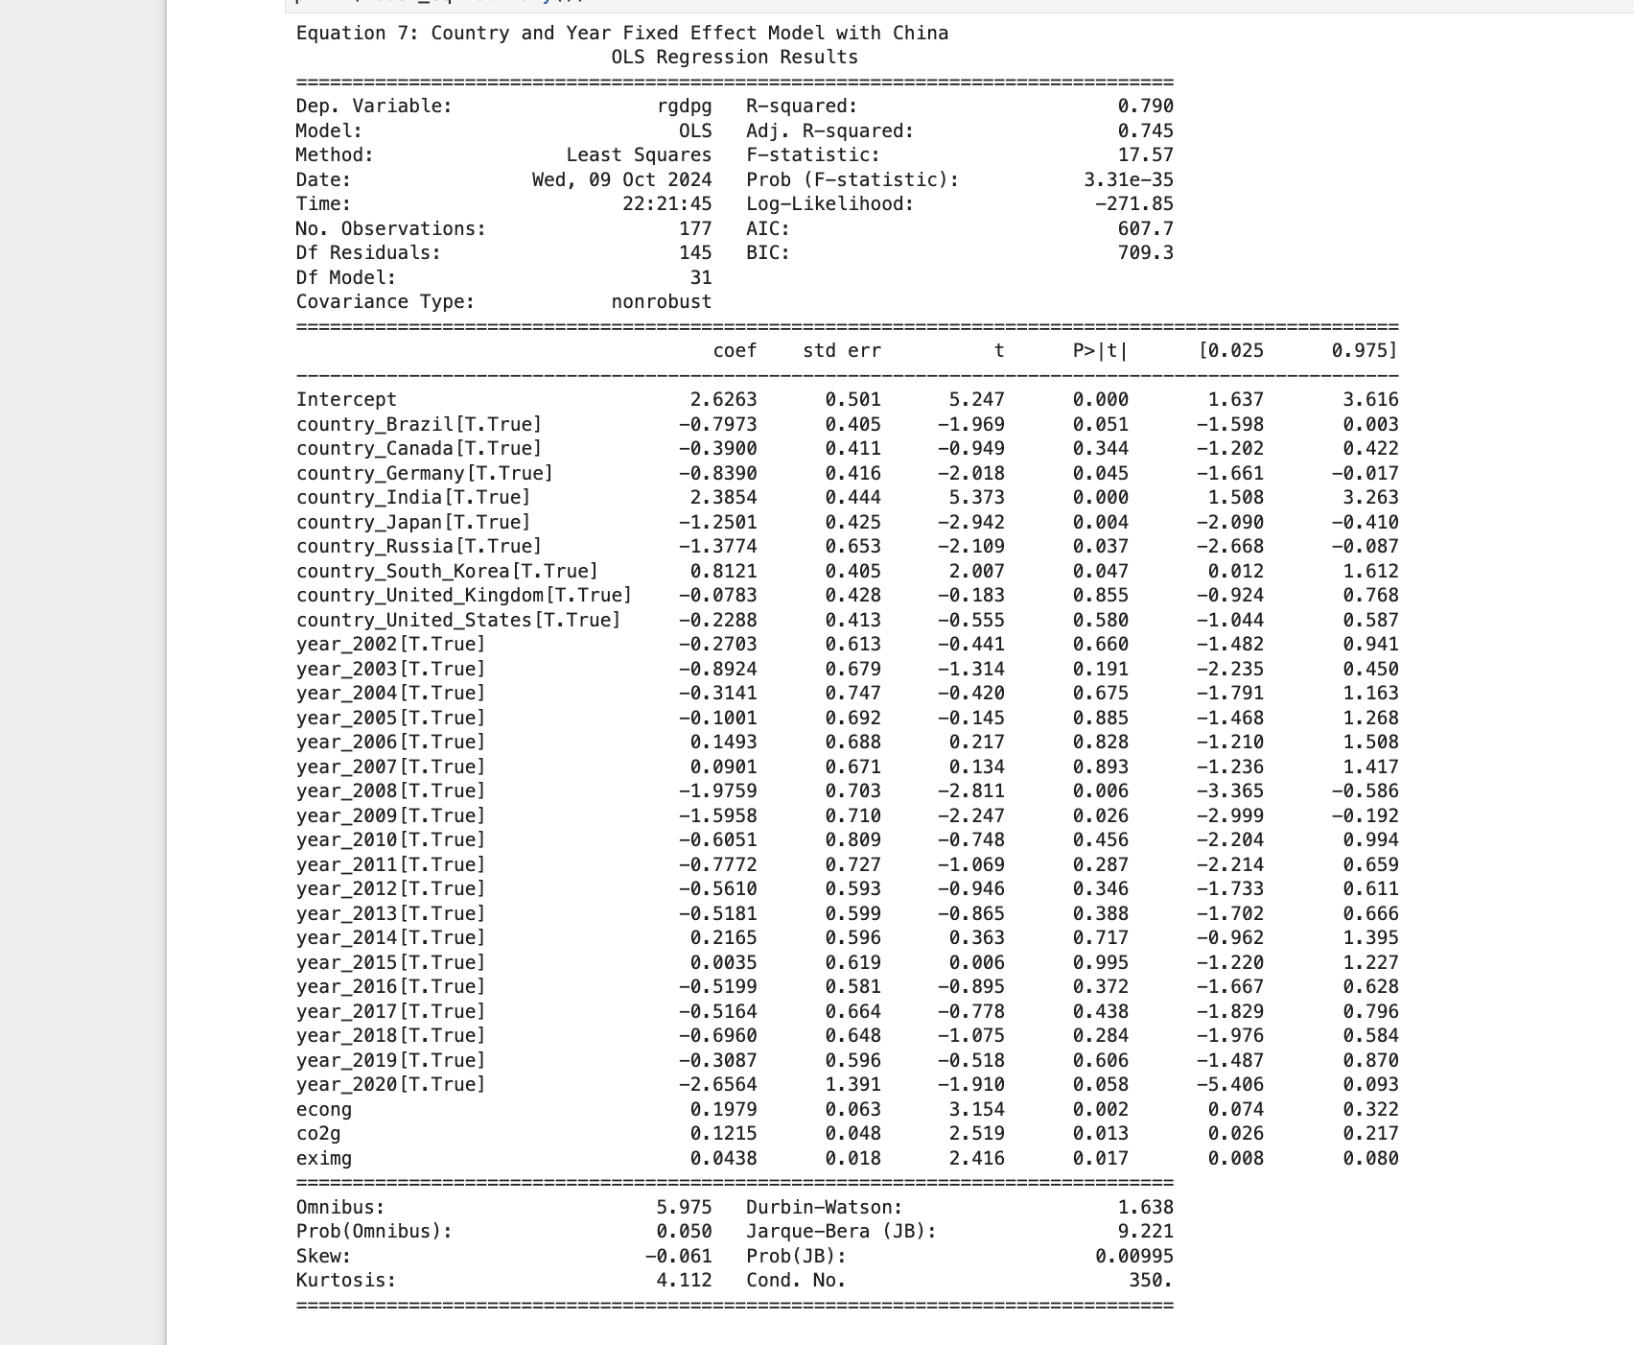

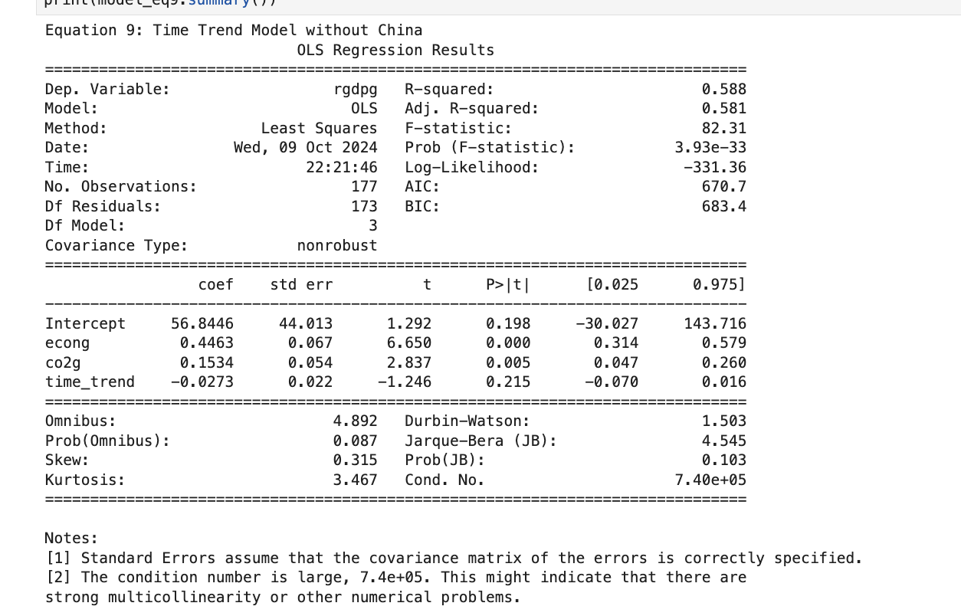

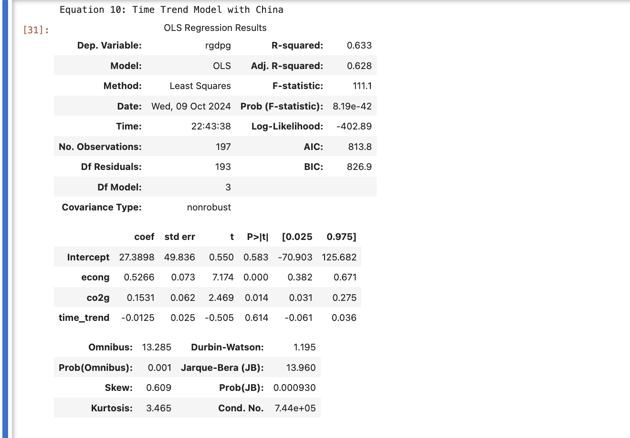

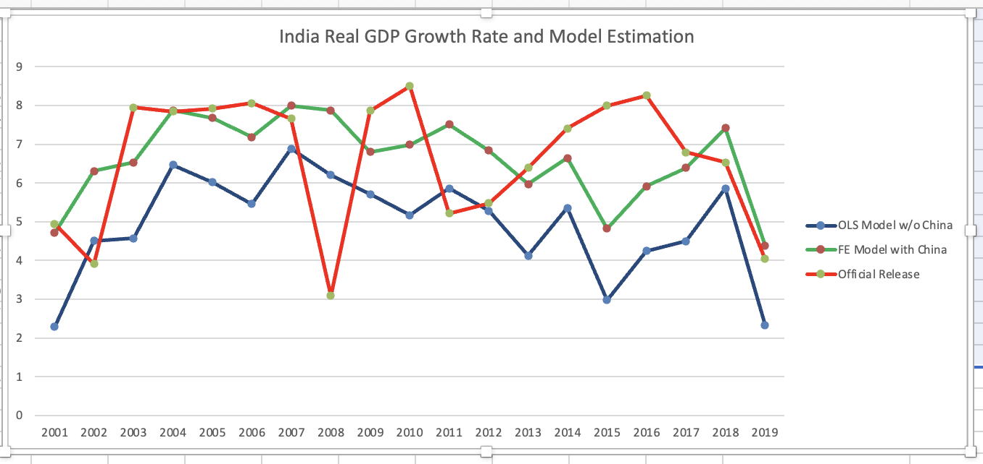

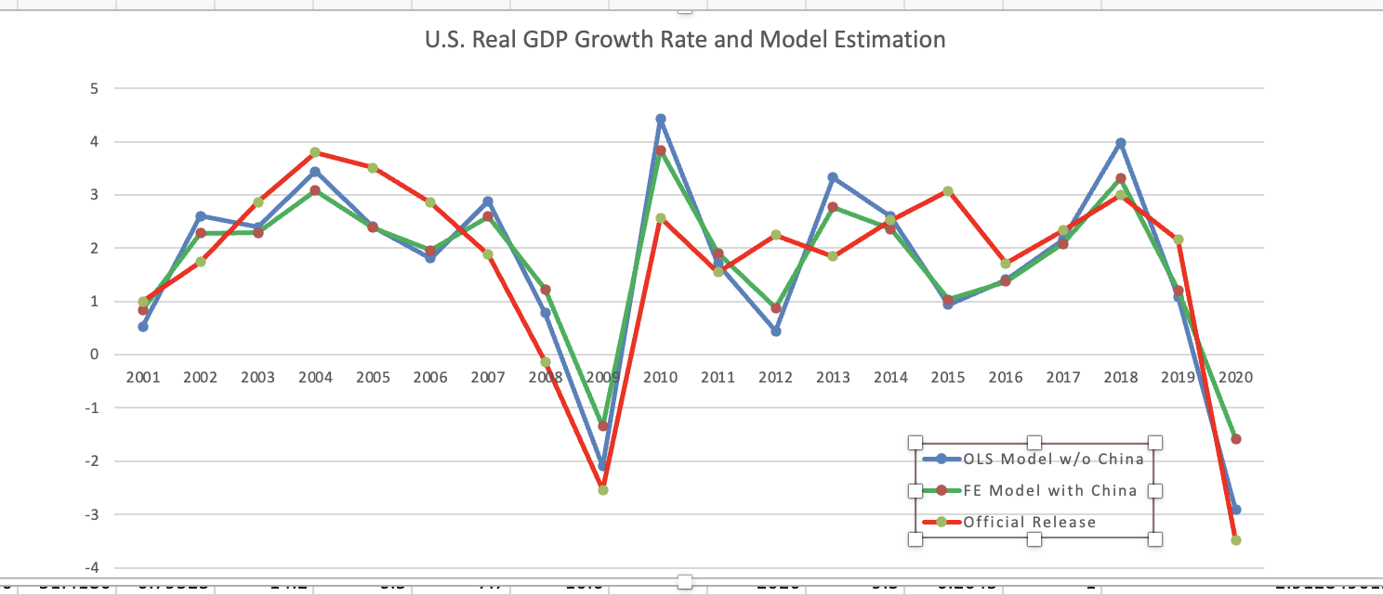

**Description Comparing All Models**

1. **Inclusion of China**:
   * Models that include China (Eq2, Eq4, Eq6, Eq8) tend to have higher coefficients for economic growth (econg) compared to those without China (Eq1, Eq3, Eq5, Eq7).
   * Including China's data amplifies the relationship between energy consumption growth (econg) and GDP growth, likely due to China's strong reliance on energy for its economic output.
2. **Fixed Effects**:
   * **Country Fixed Effects (Eq3, Eq4, Eq7, Eq8)**: The introduction of country fixed effects significantly alters the coefficients for individual countries, especially for India and Japan, which exhibit substantial positive and negative fixed effects, respectively. China consistently shows a large positive fixed effect, suggesting unique factors driving its GDP beyond the other variables considered.
   * **Year Fixed Effects (Eq5, Eq6)**: These models attempt to capture time-specific effects. Notably, certain years, such as 2008 and 2010, exhibit significant negative impacts on GDP, potentially reflecting the influence of global crises (e.g., the financial crisis).
3. **Time Trend Models (Eq9, Eq10)**:
   * The time trend variable is not significant in either model, suggesting that linear time dynamics may not be influential over the period considered, or that the other variables sufficiently capture time-related changes.
4. **Four-Variable vs. Three-Variable Models**:
   * **Equation 11** (which includes four variables, adding housing price growth hpg) shows an improved model fit (R-squared = 0.72) compared to the original three-variable model in **Equation 12** (R-squared = 0.69). The inclusion of hpg enhances explanatory power, particularly for countries like China where real estate is a major economic driver.
5. **Significance of Trade (eximg)**:
   * In nearly all models, international merchandise trade growth (eximg) remains highly significant, indicating a consistent and strong relationship with GDP growth across different country and year variations.

**Overall Comparisons:**

* **Fixed Effects Models**: Models incorporating both country and year fixed effects (Eq7, Eq8) tend to provide more nuanced insights by capturing both country-specific and time-specific variations.
* **Four-Variable Model (Eq11)**: Including housing price growth (hpg) results in a more accurate representation of GDP growth, particularly for economies where real estate has a substantial impact, such as China.
* **Country-Specific Factors**: Models with country-specific effects (Eq3, Eq4, Eq7, Eq8) highlight distinct economic behaviors for countries like India and Japan, which often diverge from broader global trends.

Part B:-

**Figure 1: Original Model (m11) Trend Analysis**

* This plot represents the trend, weekly, and yearly seasonal components identified by the original Prophet model. The trend component shows a significant dip around 2020, followed by a steady upward trend and continues to rise as you pointed out in the assignment discription. This suggests that the model interpreted the low air travel during the COVID-19 pandemic as part of a continuous upward trend, without differentiating the pandemic's temporary impact.

**Figure 2: Modified Model (m) Trend Analysis with COVID Adjustment**

plot includes the trend, holiday (COVID period), weekly, and yearly seasonal components from the modified model. The trend component still shows a dip around 2020, but the model has isolated the COVID period as a distinct holiday event, leading to a more stable trend prediction. This adjustment better captures the impact of the COVID pandemic as a temporary disruption rather than a long-term trend change.   
 **The Prophet model is not perfect However, by tweaking the model we can improve its accuracy and interpret the results more effectively**[1] "RMSE of the modified model: 188475.311592715"  
RMSE of the original model (m11): 190407.557579667"

The RMSE (Root Mean Squared Error) of the modified model is slightly lower compared to the original model. This indicates that the modified model, which incorporates the COVID-19 period as a holiday, has better prediction accuracy.